**Classroom Activity: Write a code to create nested functional components in ReactJS**

**Code:**

File Name: src/ ParentComponent

ParentComponent import React from 'react'

export default function ParentComponent() {

 // Inner function to handle some logic

 const handleClick = () => {

    alert('Welcome In Parent Componet!');

  };

  return (

    <div>

      <h1>Child component click on the button</h1>

      <ChildComponent handleClick={handleClick} />

    </div>

  );

};

const ChildComponent = ({ handleClick }) => {

  return (

    <div>

      <button onClick={handleClick}>Click Me!</button>

    </div>

  );

}

File Name: src/App.js

import React, { Component } from 'react';

import ParentComponent from './ParentComponent';

function App() {

  return (

    <div className="App">

      <ParentComponent />

    </div>

  );

}

export default App;

**OUTPUT:**

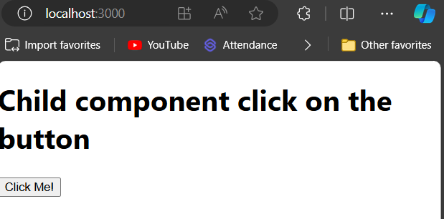

Figure: Output Screenshot (Before Click Me)

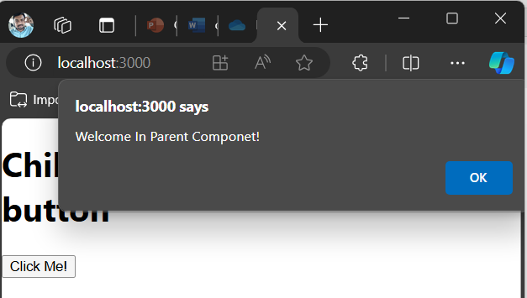

Figure: Output Screenshot (After Click Me)

**Execution Steps:**

* Write the above code
* Go to VS Code terminal
* Execute following command to run the program: npm start
* This will open your default browser and navigate to http://localhost:3000, where you will see your new React application running.